**PowerSchool**

1. Sign in to PowerSchool

2. Select your Tri-Tech course from the list at the top of the screen: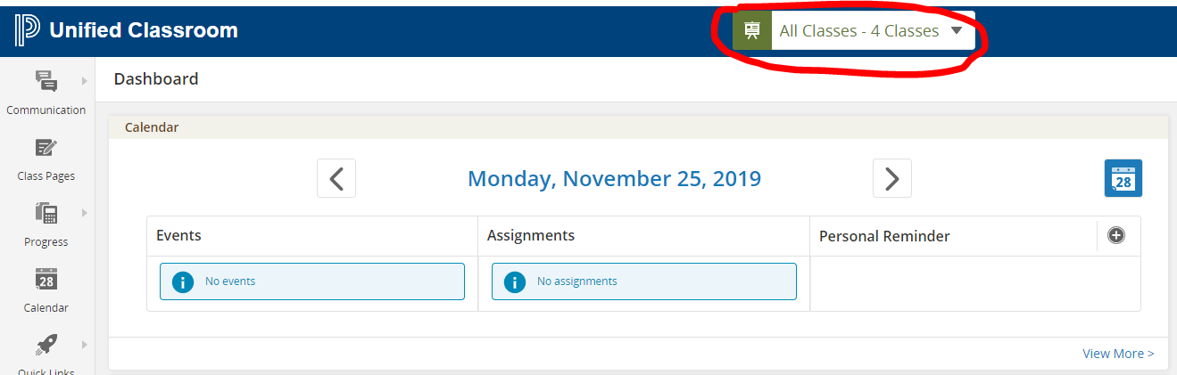

3. Ensure you select your class, and Semester 1:

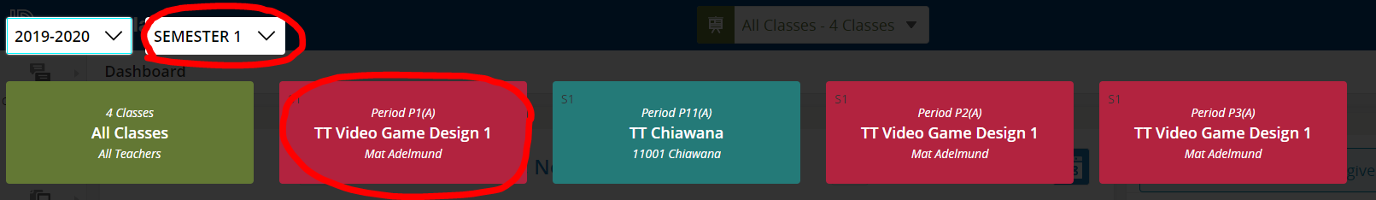

4. Press “Ctrl+P” to bring up the Print window

5. Set the destination to “Save as PDF”, and click Save

